RDVLF-Z80Y Very Low Frequency HV Test Set
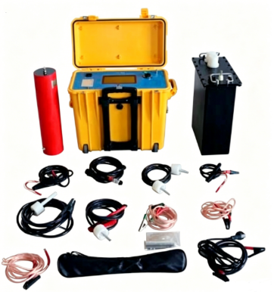
The withstand voltage test is divided into two categories: AC and DC. The AC withstand voltage includes technologies such as power frequency, variable frequency, and 0.1Hz very-low frequency. As the latest testing solution recommended by the International Electrotechnical Commission (IEC), the 0.1Hz very-low frequency technology has significant technical advantages.
RDVLF-Z80Y features auto-variable frequency (0.1–0.01Hz) true sine wave output, with a color touchscreen that displays voltage and current waveforms in real time. It incorporates safe optical isolation, closed-loop negative feedback, and overvoltage/overcurrent protection. Direct sampling on the HV side ensures accurate data. Built-in printer and protective resistors are included, with support for result storage and printing. Portable and rugged, it is ideal for on-site AC withstand voltage testing.
- Product features
- AC Withstand voltage testing, Voltage & current curve display.
- Safe Optical isolation technology.
- Easiest to use Fully automatic microcontroller.
- H/L voltage closed loop negative feedback control circuit, output no capacity rise effect.
- Built-in printer.
- Built-in protective resistors.
- Color Touch LCD (154*86mm) operation, True sine wave output.
- Real-time display of actual output waveform.
- Ergonomic, menu guided, large color touch screen
- Storage of test results for later retrieval and print.
- Over voltage and current protected.
- Auto variable frequency 0.1Hz, 0.05Hz, 0.02 Hz, 0.01 Hz.
- 60 mins continuous working;
- Data of current, voltage and waveform directly sampled at HV side.
- Portable rugged and reliable trunk design (box material is special mixed resin, made in USA).
- RS232/USB for buyer’s option (Default configuration of USB interface).
- DC withstand voltage test and DC leakage current test function (optional).
- Product specifications and technical parameters
- Power: 220V ± 10% AC (110V can be customized), 50/60Hz, single phase;
- AC output-Voltage (Peak): 80 KV
- Output frequency: 0.1Hz, 0.05Hz, 0.02 Hz, 0.01 Hz (auto variable frequency);
- Load: 0.5μF @ 0.1 Hz; 1.0μF @ 0.05 Hz; 2.0μF @ 0.02 Hz; 4.0μF @ 0.01 Hz
- Stability of frequency: Fluctuation < 0.5%;
- AC voltage measurement accuracy: ±3%;
- AC voltage measurement resolution: 0.1KV;
- AC current measurement accuracy: ±3%;
- AC current measurement 0-20mA, resolution: 0.1mA;
- Positive and negative voltage peak error: ≤3%;
- Voltage waveform distortion: ≤3%;
- Construction: 1*40KV integrated device + 1*40KV external booster
- DC leakage current measurement (optional)
DC output rated voltage: +80kV DC voltage accuracy: 3%
DC leakage current range: 0-2000μA DC leakage current resolution: 1μA
DC leakage current accuracy: 3%
- Ambient conditions of use: temperature Indoor and outdoor : -10ºC ～ + 50ºC.
- Humidity: ≤85%

